Scanning Networks
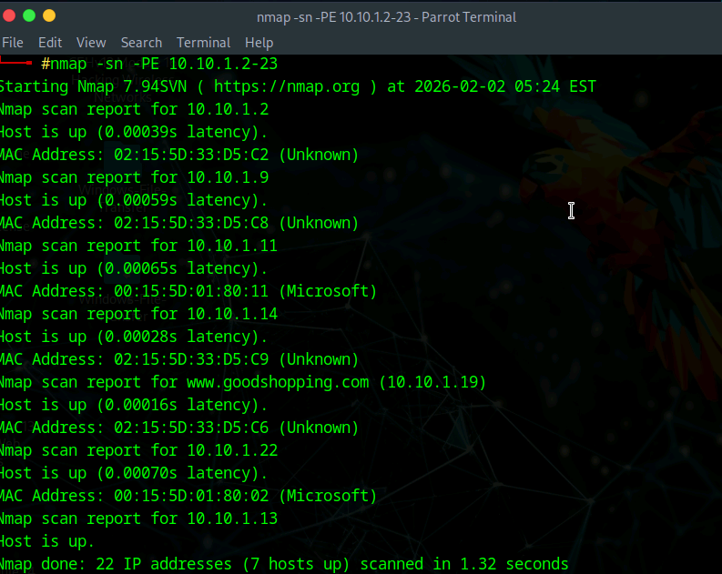
Southants Solutions is at risk If an attacker were to perform host discovery on their systems using Nmap. This could very easily allow the attacker to identify the IoT system that controls their wind and solar farms. Due to IoT systems typically not having the best security and can often expose open ports, this can allow the attacker easy access and control of their systems, potentially disrupting the farms themselves. Attackers could may also access the servers hosting the website and extranet, which puts their customers at immediate risk as well, and any remote access systems, potentially through any Vlans. Overall, this creates a network topology for the attacker, giving them an insight into the company infrastructure. As a pentester, I could use host discovery using Nmap to build a map of the hosts and ip addresses within the network and identify the exposed assets in the network and focus on the security of the most often targeted assets like IoT systems, employee devices and file systems.
Fig 1. Host Discovery using NMap
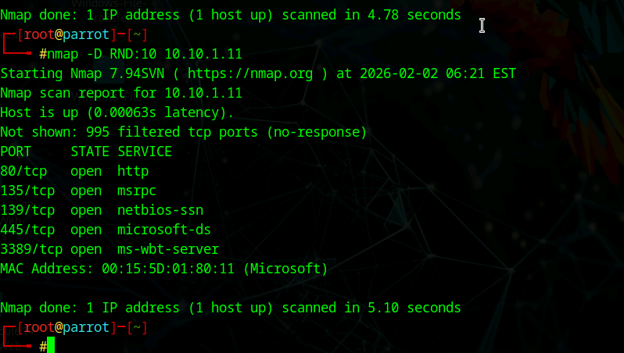
Fig 2. Scanning beyond firewall with Nmap
Southants Solutions systems are also vulnerable to firewall evasions and decoy scans, as seen in figure 2. Due to the lack of security IoT systems typically have, and also that the security is a concern to the company in the first place, it means its very easy for attackers to scan open ports undetected using decoy scans and bypassing any security the systems may have. This can also expose the energy systems from the farms, customers data on the extranet and servers in several of their branches, like Bournemouth, Portsmouth and Basingstoke. Due to decoy scanning, attackers could map the entire network and go undetected, as logs can show many Ip addresses which mask which one is actively scanning the network maliciously, making mitigating the attack much harder and putting the company at a risk as a whole. I can use these techniques as a pentester to chekck how well the Southants Solutions network identifies a real attack from misleading traffic and if it can distinguish the two and make an alert of the real one and also if their firewall can resist evasion techniques as a weak firewall could allow for exposure of services and let attackers map the enviromet quietly and quickly
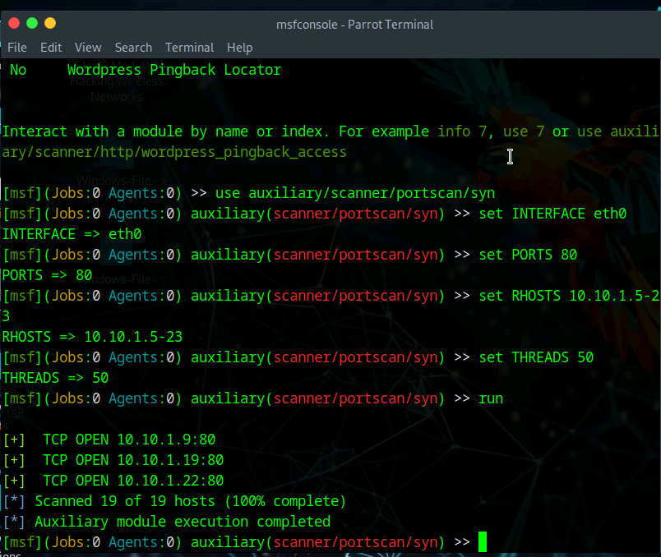
Fig 3. Scanning a network using metasploit
Metasploit can be used as a threat by an attacker against Southants Solutions as it can discover weaknesses within their systems through live hosts, open ports or OS versions. This could lead on to an attacker finding the systems that connect all their branches and due to Southants Solutions having a number of locations, it can be easy for attackers to find several entry points within the network. As a result, this can cause several disruptions to their visibility into operations and services at the wind and solar farms and as a company that relies heavily on monitoring these through IoT devices, it can be seen as a serious issue. However, as a pentester, Metasploit can be useful as it gives me insight into what an attacker could learn and where weaknesses can be found. The main things that would need to be protected for Southants Solutions would be their IoT systems, the extranet used by their customers and their devices used by staff
Reference List:
Keary, T. 2019. 10 Best Tips for Using Metasploit to Harden your network. [Accessed March 2026] Link: https://www.cyberdefensemagazine.com/10-best-tips/
Editorial Team. 2022. Metasploit: Best Penetration Testing Software. [Accessed March 2026] Link: https://diesec.com/2022/07/metasploit-best-penetration-testing-software/
Goud, K. 2025/2026. Metasploit Framework for Network Penetration Testing [Accessed April 2026] Link: https://www.studocu.com/in/document/jawaharlal-nehru-technological-university-hyderabad/cse-cyber-security/case-study-metasploit-framework-for-network-pen-testing-cs11/148194621
Mulumba, P and Cipa, P. 2025. Analysis of Cyberattacks via the Metasploit Framework and Solutions Proposal. [Accessed April 2026] Link: https://ijeais.org/wp-content/uploads/2025/9/IJEAIS250921.pdf
Geeksforgeeks. 2025. Host Discovery using Nmap Network Scanning [Accessed April 2026] Link: https://www.geeksforgeeks.org/linux-unix/host-discovery-in-nmap-network-scanning/
Nmap. 2010. Host Discovery. [Accessed March 2026] Link: https://nmap.org/book/man-host-discovery.html
Nmap. 2010. Chapter 3. Host Discovery (Ping Scanning). [Accessed March 2026] Link: https://nmap.org/book/host-discovery.html
Administrator. 2012. Nmap-Techniques for avoiding firewalls.[Accessed March 2026] Link: https://pentestlab.blog/2012/04/02/nmap-techniques-for-avoiding-firewalls/
Kanishka10. 2024. Popular firewall bypass techniques. [Accessed March 2026] Link: https://hackercoolmagazine.com/popular-firewall-bypass-techniques/
Bogert, J. 2022. Nmap firewall evasion techniques guide for effective security testing.[Accessed April 2026] Link: https://linuxsecurity.com/features/nmap-firewall-evasion-techniques
Nmap. 2010. Subverting Intrusion detection systems .[Accessed April 2026] Link: https://nmap.org/book/subvert-ids.html

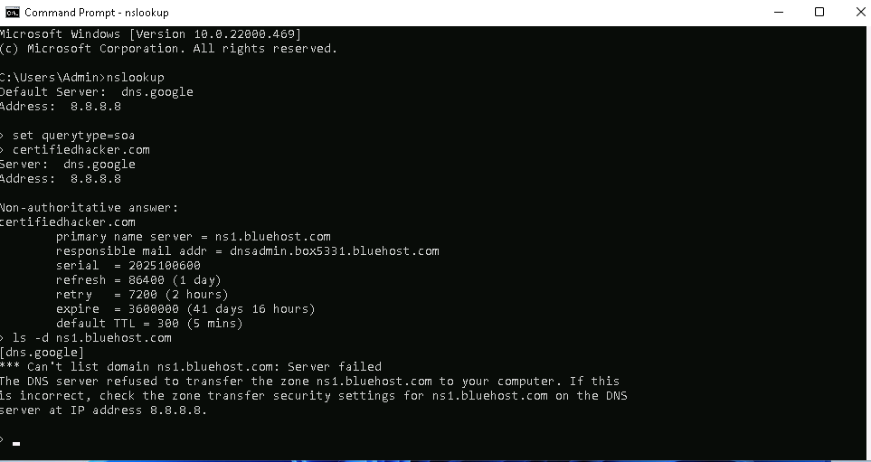
Enumeration

Fig 4. DNS enumeration with Zone transfer in CMD

DNS Zone Transfer can prove a threat to Southants Solutions through their IoT system that is monitored in their Head Office in Southampton. This can be dangerous for them due to the amount of information that can be exposed through a zone transfer, like ip addresses, DNS records that could only be found this way and monitor patterns that can help attackers with attacks later on, like phishing. As a pentester, I can use a zone transfer to see how exposed Southants Solutions DNS is. This can be fixed by tightening control on zone transfers to limit exposure as a company using public facing systems like extranets.

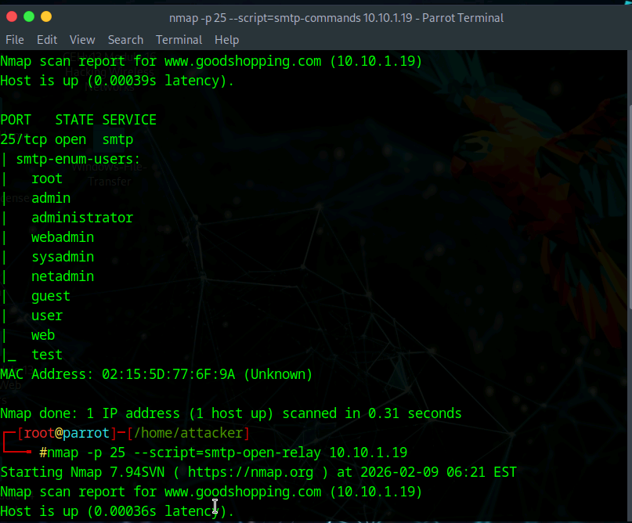

Fig 5. SMTP Enumeration
SMTP enumeration can be used by an attacker to reveal users and email addresses on the mail server on specific ports, like port 25. This could lead to attackers being able to easily build a map within the Southants Solutions network on who to target with phishing attacks and what the structure is like within the company. Due to Southants Solutions being very customer facing and having several offices, this can make it easy for an attacker to gain access to operational systems through attacks like spear phishing and eventually gain higher access within the company if compromised. As a pentester, I could use SMTP enumeration to test security on mail systems and see how exposed names are to unauthenticated users. This can be improved by reducing rate limit requests and restrict information and behaviors by the SMTP server to reduce the company vulnerability.
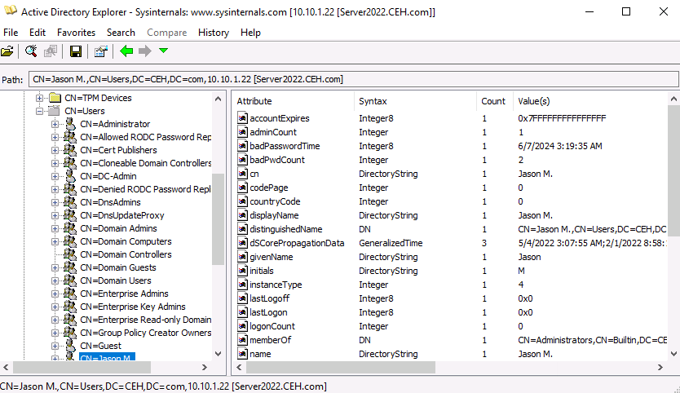
Fig 6. LDAP using AD Explorer
LDAP enumeration is dangerous for Southants Solutions due to the fact that users, groups and their privileges can be easily exposed within Active Directory. This can help an attacker build a portfolio on who within the company has access where to make attacks more targeted in certain areas, like finance or sales departments, and how to gain admin privileges through escalation once inside the network. Attackers can very easily build a map of the hierarchy of the company in terms of who has the highest privileges in the directory to make it easier to impersonate them or others. As a pentester, I can use LDAP in AD to find out how much authenticated and unauthenticated users can see. If unauthenticated users can see too much, this helps to then fix this issue by tightening access control and more restrictions on viewing the directories by reducing privileges on how much users can access in their own and other department directories.

Reference List:
Parker, J. 2025. What is a Zone transfer and how can it be misused? [Accessed April 2026] Link: https://www.cyberly.org/en/what-is-a-zone-transfer-and-how-can-it-be-misused/index.html
Danopoulos, N. 2016. DNS enumeration techniques in Linux [Accessed April 2026] Link: https://www.infosecinstitute.com/resources/penetration-testing/dns-enumeration-techniques-in-linux/
Jumpcloud. 2025. What is DNS zone transfer? [Accessed April 2026] Link: https://jumpcloud.com/it-index/what-is-dns-zone-transfer
LuemmelSec. 2020. Pentest-Everything SMTP. [Accssed April 2026] Link: https://luemmelsec.github.io/Pentest-Everything-SMTP/
PEN consultants. 2018. Enumeration Vulnerability in Leading Email Providers. [Accessed April 2026] Link: https://penconsultants.com/blog/online-security/enumeration-vulnerability-in-leading-email-providers/
Geeksforgeeks. 2025. SMTP enumeration. [Accessed April 2026] Link: http://geeksforgeeks.org/ethical-hacking/smtp-enumeration/
ScarredMonk. 2019. Active Directory Penetration Dojo-AD environment Enumeration -1 [Accessed April 2026] Link: https://0xdarkvortex.dev/active-directory-penetration-dojo-ad-environment-enumeration-1/

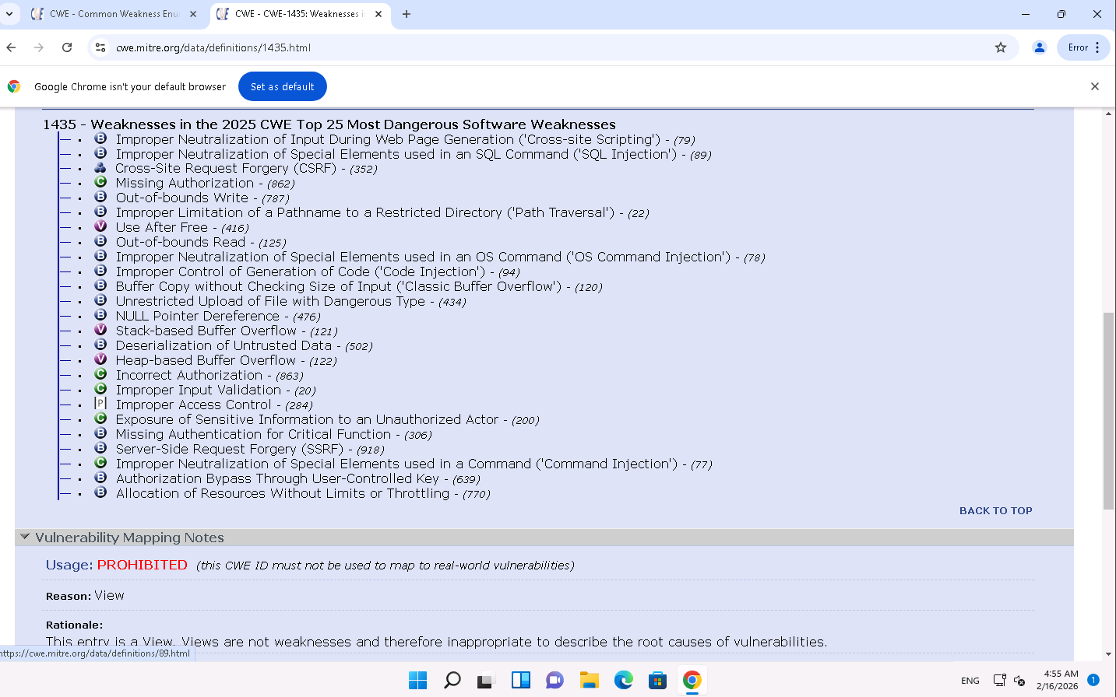
Vulnerability Analysis
Fig 7. CWE list

The CWE can be vital to me as a pentester for the security of Southants Solutions network but also to attackers on what weaknesses Southants Solutions could have. Attackers can use the cwe as a way to map out the weaknesses Southants Solutions has in their systems, leading to potential disruptions with the remote monitoring of their farms or communications between their sites. As a pentester, I can use the CWE as a checklist to see the vulnerabilities in the systems and test to see what is causing the biggest impact. I would be able to see what can pose a threat to their systems, why its causing a problem, like exposure of sensitive information, and how this can be fixed. It also allows me to recommend specifics in how Southants Solutions can secure their systems better, whether it could be limiting how much information staff expose on the public website or tightening security throughout the network.
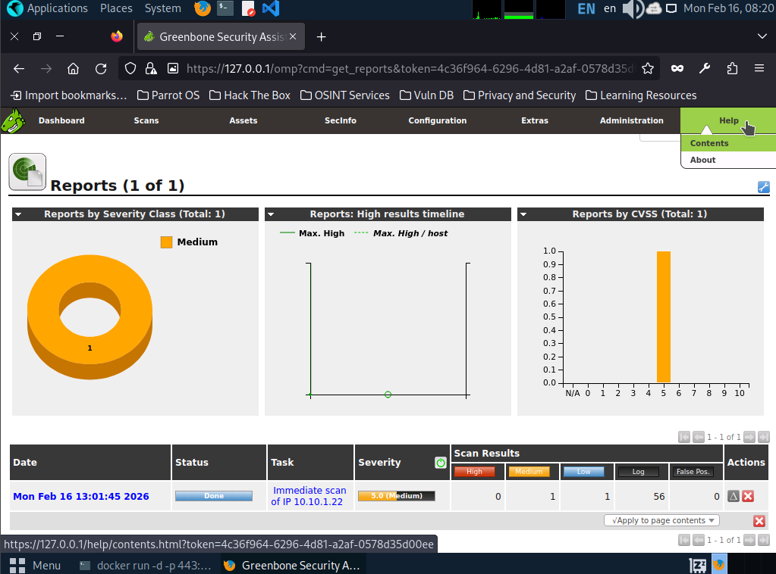
A vulnerability Scanner could be used by an attacker to discover exposed weaknesses in Southants Solutions systems. This could include open ports to access their IoT systems or weak points within the website and extranet to allow for attackers to work their way inwards from an external easily reachable point. As a pentester, I can use a vulnerability scanner to create a list of known issues within the Southants Solutions systems and then narrow down the most harmful or important issues myself to differentiate between noisy scans and exploitable vulnerabilities and not disrupt their systems by creating too much network traffic for the It and operational systems.
Fig 8. Vulnerability Scanner
Reference List:
Walker,N. 2025. 2025 CWE Top 25 Most Dangerous Software Weaknesses. [Accessed April 2026] Link: https://www.cip-association.org/2025-cwe-top-25-most-dangerous-software-weaknesses/
CWE.2025. CWE Top 25 Most Dangerous Software Weaknesses. [Accessed April 2026]. Link: https://cwe.mitre.org/top25/
Perforce. 2025. What is CWE? Overview + CWE top 25. [Accessed April 2026] Link: https://www.perforce.com/blog/kw/what-is-cwe
Lee,I. 2021. CWE-Common Weakness Enumeration [Accessed April 2026] Link: https://www.wallarm.com/what/cwe-common-weakness-enumeration
Richard D. 2021. Vulnerability Scanning: Keeping on top of the most common threats [Accessed April 2026] Link: https://www.ncsc.gov.uk/blog-post/vulnerability-scanning-keeping-on-top-of-the-most-common-threats
TACSecurity. 2024. Navigating the Complex World of Vulnerability Scanning: A Guide for Organizations [Accessed April 2026] Link: https://tacsecurity.com/navigating-the-complex-world-of-vulnerability-scanning-a-guide-for-organizations/
Dach,T. 2024. 5 Best Network Vulnerability Scanning Tools in 2024 [Accessed April 2026] Link: https://www.algosec.com/blog/network-vulnerability-scanning-tools
Paloalto Networks. What is Vulnerability Scanning. [Accessed April 2026] Link: https://www.paloaltonetworks.com/cyberpedia/vulnerability-scanning
Kosinski,M and Forrest,A. What is Vulnerability Scanning? [Accessed April 2026] Link: https://www.ibm.com/think/topics/vulnerability-scanning

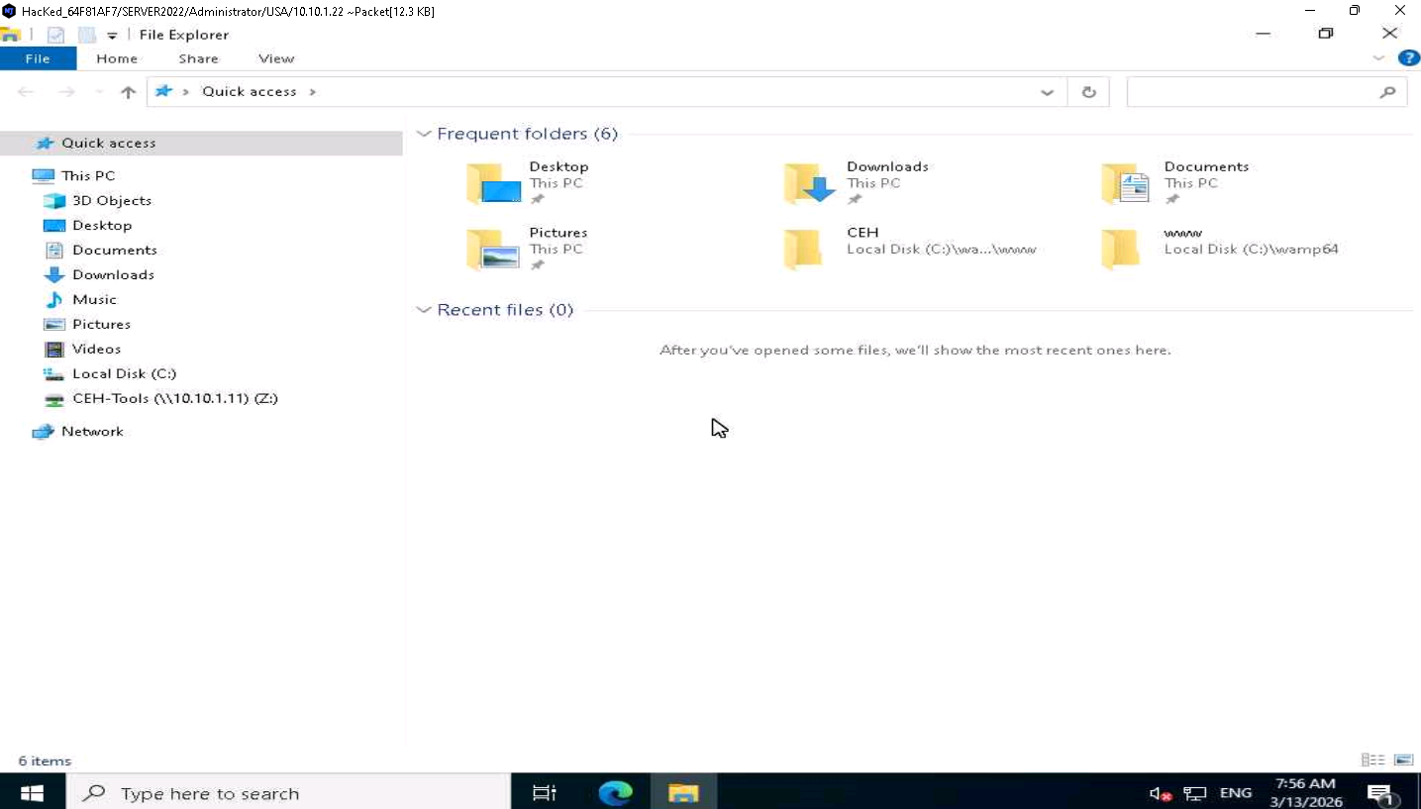
Malware Threats

An attacker using remote access to gain entry to the Southants Solutions systems is a huge issue and risk as they could very easily gain access to and move around the network without anybody knowing. One key way they could gain access is through the remote monitoring of their wind and solar farms on the IoT system, which could lead to operational disruptions as well as data leaks, access to other systems and departments like finance and malware being spread across the network. As a pentester, I could use any trojans or spyware to see how well Southants Solutions systems can defend against it and whether an attacker could legitimately gain access. I can then use this to see how strong the remote access across the company is, as this is most likely a key part of everyday operations across various sites with 200 employees. This can be easily fixed by enforcing MFA, ensuring all remote systems don’t have any weaknesses and ensure any mobile devices and external remote access is controlled and monitored correctly.
Fig 9. Remote access to the target machine

Fig 10. Infected target system with a virus
The Southants Solutions systems being infected with a virus could lead to data loss and disruptions across the network, causing major problems for the company as they have several offices, mobile staff, a extranet and customer facing website and their main monitoring system is an IoT system in their head office, meaning one virus could spread very quickly without the proper precautions and security in place. As a pentester, I can use a virus to test how well their systems can detect the malware and prevent it from causing significant damage by making sure endpoints are protected, there is suitable segmentation and that there are regular backups for the systems to recover to incase of a major issue. This can all be done safely to test and ensure that the infected systems can contain the virus and prevent a chain reaction could damage the whole network.
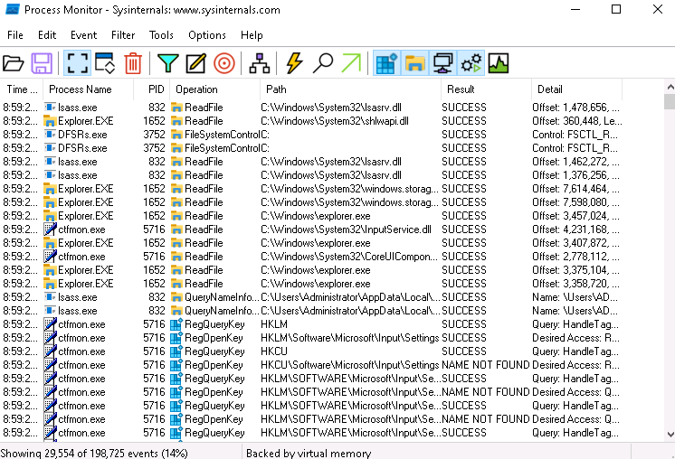

Fig 11. Monitoring with process monitor

Using a process monitor for Southants Solutions systems can be dangerous if used by an attacker but extremely useful if used by a pentester. An attacker can use a process monitor to see any logged in users, active processes, pathways of important files and applications and find the best place to insert malware to spread silently across the system. This helps them gather more useful information on the system and find the best times to disrupt systems. This could cause severe issues on the customer facing systems and extranet and also help gain access to move across the different sites. As a pentester, I can use process monitoring to see how Southants Solutions reacts to unauthorized processes and see how quickly the system can react to the early signs of issues and malware to allow the security team to handle it. Overall any suspicious activity should be easier to notice and investigate when using a process monitor and can be used as a useful tool for detection.

Reference List:
Cyber Management Alliance. 2025. How Remote Access Trojans Impact Organizational Security & Compliance. [Accessed April 2026] Link: https://www.cm-alliance.com/cybersecurity-blog/how-remote-access-trojans-impact-organizational-security-compliance
RealVNC. 2025. Remote Access Attacks 2025: Statistics, Real Examples & How to Prevent RDP Exploitation. [Accessed April 2026] Link: https://www.realvnc.com/en/blog/remote-access-attacks/
Macris, D. 2025. Understanding OT Remote Access Threats, Vulnerabilities and Mitigation Strategies [Accessed April 2026] Link: https://dispel.com/blog/understanding-ot-remote-access-threats-vulnerabilities-and-mitigation-strategies
Geeksforgeeks. 2025. Remote Access in Ethical Hacking. [Accessed April 2026] Link: https://www.geeksforgeeks.org/ethical-hacking/remote-access-in-ethical-hacking/
Mazerik, R. 2014. Remote Access Tool. [Accessed April 2026] Link: https://www.infosecinstitute.com/resources/hacking/remote-access-tool/
Veridify Security. 2023. How Malware can impact OT networks. [Accessed April 2026] Link: https://www.veridify.com/article/how-malware-can-impact-ot-networks/
Diaz, A. 2026. Cyberattacks in OT/IT Environments: Analysis and Potential Solutions to a Growing Trend. [Accessed April 2026] Link: https://assetmanagementprofessionals.org/news-articles/cyberattacks-in-ot-it-environments-analysis-and-potential-solutions-to-a-growing-trend/
Reason Labs. What is Process Monitoring. [Accessed April 2026] Link: https://cyberpedia.reasonlabs.com/EN/process%20monitoring.html
Protecht. 2025. Continuous risk monitoring: Best practices for complex risk management. [Accessed April 2026] Link: https://www.protechtgroup.com/en-gb/blog/continuous-risk-monitoring-best-practices-for-complex-risk-management

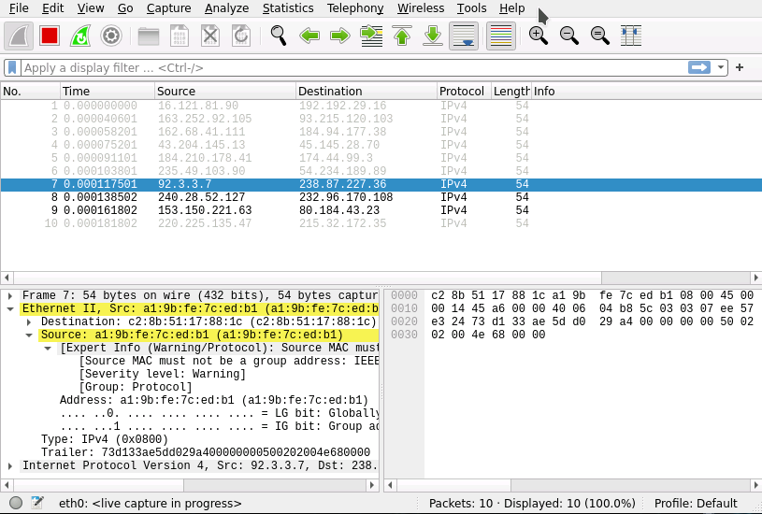
A DHCP starvation attack can be severe for Southants Solutions if used by an attacker due to the fact that they have many systems and sites that rely on network connectivity, this can stop any services from running and devices from being able to connect to the network. This attack can affect a majority of the business at once, like preventing the mobile maintenance and engineering staff from connecting remotely, or preventing customers from accessing the website and extranet. As a pentester, DHCP starvation can be used to test if Southants Solutions can recognize and prevent the early stages of address pool exhaustion before it becomes a bigger threat. The main protections I would need to check for are DHCP snooping, port security and rate limiting to ensure their layer 2 security is efficient and that they are monitoring for any such attacks.
Fig 12. DHCP Starvation Attack
Sniffing
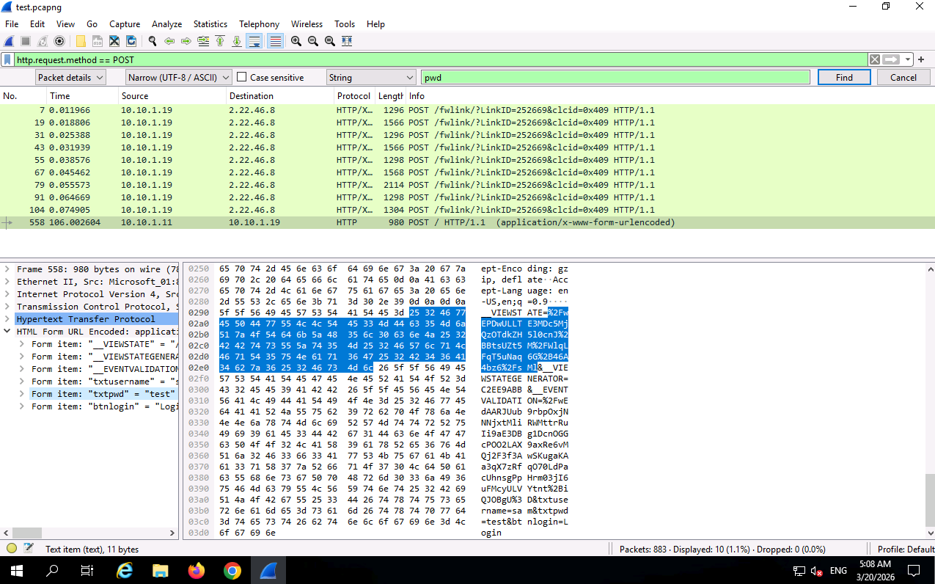
Fig 13. Password Sniffing using Wireshark

Password Sniffing can be useful or dangerous for Southants Solutions depending on the situation. An attacker can quickly compromise accounts and move throughout the network just by capturing traffic and finding key credentials from HTTP or FTP services that aren’t fully encrypted. This could be done through intercepting the traffic between sites or on the extranet which customers publicly use. As a pentester, I can use password sniffing to see if the traffic across the Southants Solutions network flags any unencrypted data like usernames and passwords or if it is visible when traffic is monitored normally. This can be fixed by tightening network segmentation and amending encryption to make sure sensitive information can’t be viewed by anybody on the network monitoring and capturing traffic.
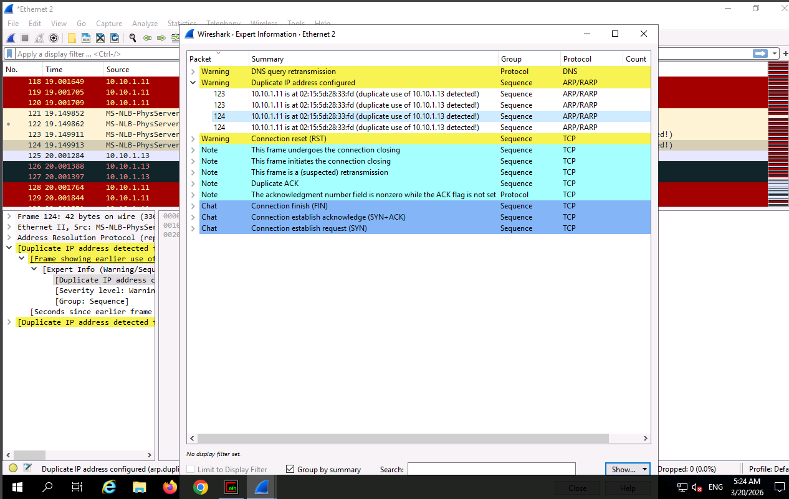
ARP poisoning can be used maliciously by an attacker to disrupt and alter traffic flow across the network. By poisoning the ARP tables, traffic can be redirected through them, intercepting data like usernames and passwords. This could affect many of the sites, offices and employees within them, the IoT system used for monitoring the farms and the customer facing systems like the extranet and website, where customers data can be taken from. As a pentester, I can use ARP poisoning to see how the Southants Solutions system responds to the attack and if preventions like port security, encrypted protocols and ARP inspection can identify and prevent any intercepted attacks. I can also use wireshark as a way to monitor the effects of the attack and see if the Southants systems can detect duplicate IP’s and the rerouting of traffic through an attackers system.
Fig 14. Detecting ARP Poisoning
Reference List:
Geeksforgeeks. 2025. Mitigation of DHCP starvation attack. [Accessed April 2026] Link: https://www.geeksforgeeks.org/ethical-hacking/mitigation-of-dhcp-starvation-attack/
Khalil, M. 2026. What Is DHCP Starvation? How IP Exhaustion Attacks Work. [Accessed April 2026] Link: https://deepstrike.io/blog/what-is-dhcp-starvation
Dhandala, N. 2026. How to Prevent DHCP Starvation Attacks. [Accessed April 2026] Link: https://oneuptime.com/blog/post/2026-03-20-prevent-dhcp-starvation-attacks/view
Clancy, R. Password Sniffing in Ethical Hacking and Its Types Explained. [Accessed April 2026] Link: https://www.eccouncil.org/cybersecurity-exchange/ethical-hacking/ethical-hacking-password-sniffing/
Geeksforgeeks. 2023. Sniffing of Login Credential or Password Capturing in Wireshark. [Accessed April 2026] Link: https://www.geeksforgeeks.org/ethical-hacking/sniffing-of-login-credential-or-password-capturing-in-wireshark/
Drzewiecki, P. 2025. ARP spoofing – how to detect a Man-in-the-Middle attack and ARP poisoning in a LAN network. [Accessed April 2026] Link: https://www.sycope.com/post/arp-spoofing-how-to-detect-a-man-in-the-middle-attack-and-arp-poisoning-in-a-lan-network
SentinelOne. 2025. What is ARP Spoofing? Risks, Detection, and Prevention. [Accessed April 2026] Link: https://www.sentinelone.com/cybersecurity-101/threat-intelligence/arp-spoofing/

Social Engineering

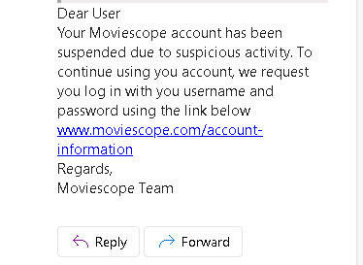

Fig 15.Using SET to send a phishing email
Phishing emails created using SET can have major effects on Southants Solutions, particularly the people who are targeted if this is a real attack. If these phishing emails are sent by a real attacker with malicious intent, they can convincingly trick people into clicking a link or sending sensitive details which can allow an attacker to gain further access into accounts, the extranet or internal systems like finance or sales departments if an employee is targeted. Due to the company having 200 employees, many customers using the website and extranet and multiple sites across Hampshire, there is a wide range of targets for the attacker to target with a phishing email. As a pentester, I can utilize a phishing email to test particularly employee awareness, how the emails are filtered, and how effective the incident response is in the case of someone clicking the link. The goal would be to gain a picture of how vulnerable Southants Solutions is to social engineering in general and if employees need to be educated on the matter, if there are precautions in place to prevent employees from accidentally clicking dangerous links and if there is effective damage control to recover from the situation.

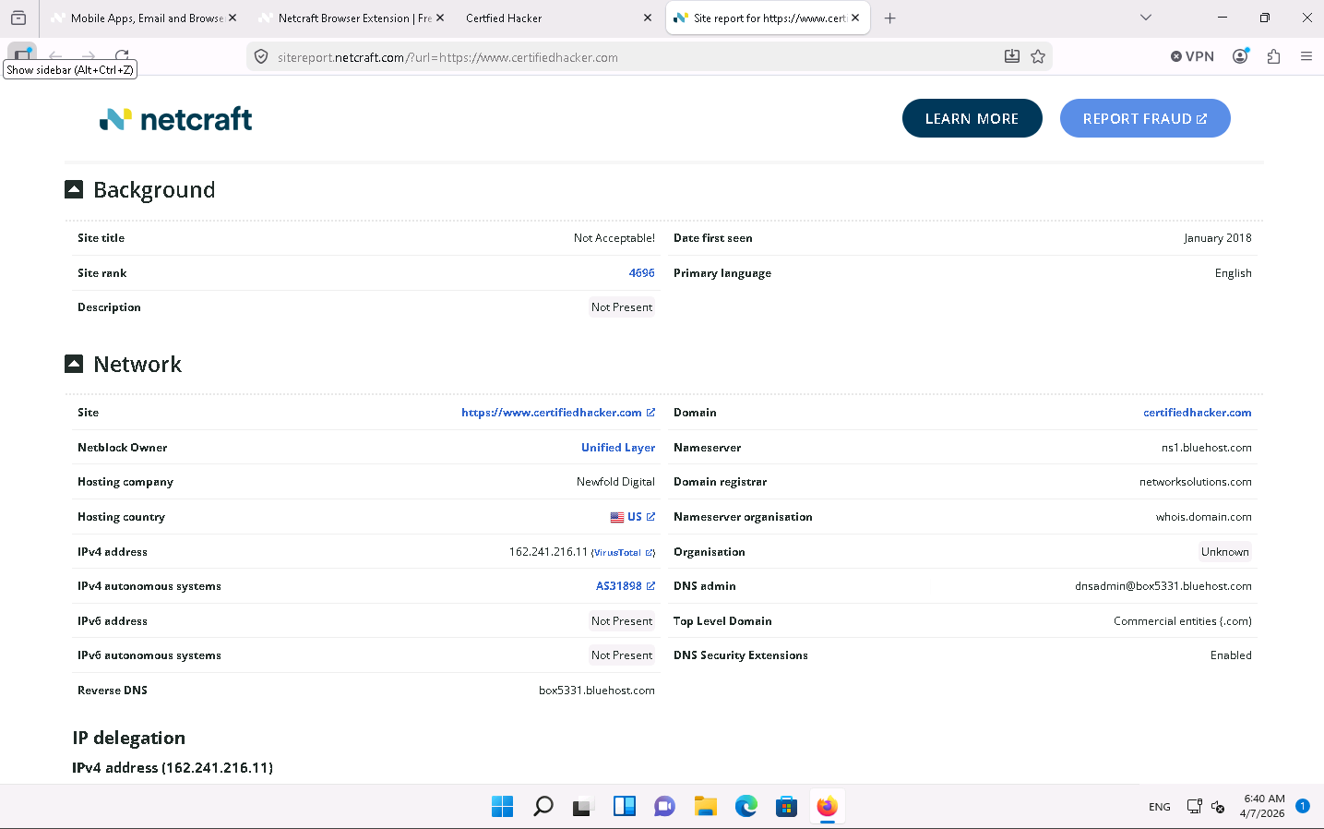
Fig 16.Detect Phishing using Netcraft
Netcraft is a useful company that can provide effective information on how susceptible Southants Solutions could be to a phishing attack. By continually monitoring domains and phishing indicators, Netcraft can be used a prevention tool for customers and employees in the case of any phishing attacks that could damage the company. As a pentester, I can use Netcraft as a way to identify any fake websites, impersonations or threats that Southants Solutions could be at risk of or if attacks are currently taking place. These attacks would be most prevalent around the extranet and website where customers could be logging in and accessing sensitive data, and with staff accounts in the various departments. Netcraft is a good tool to help Southats Solutions understand how attractive their information could be to attackers and where the exposed points are if attacks have already taken place without their knowledge. As a business with several sites around Hampshire and reliant on customer facing systems, the insight can be very helpful to prevent attacks and strengthen systems.

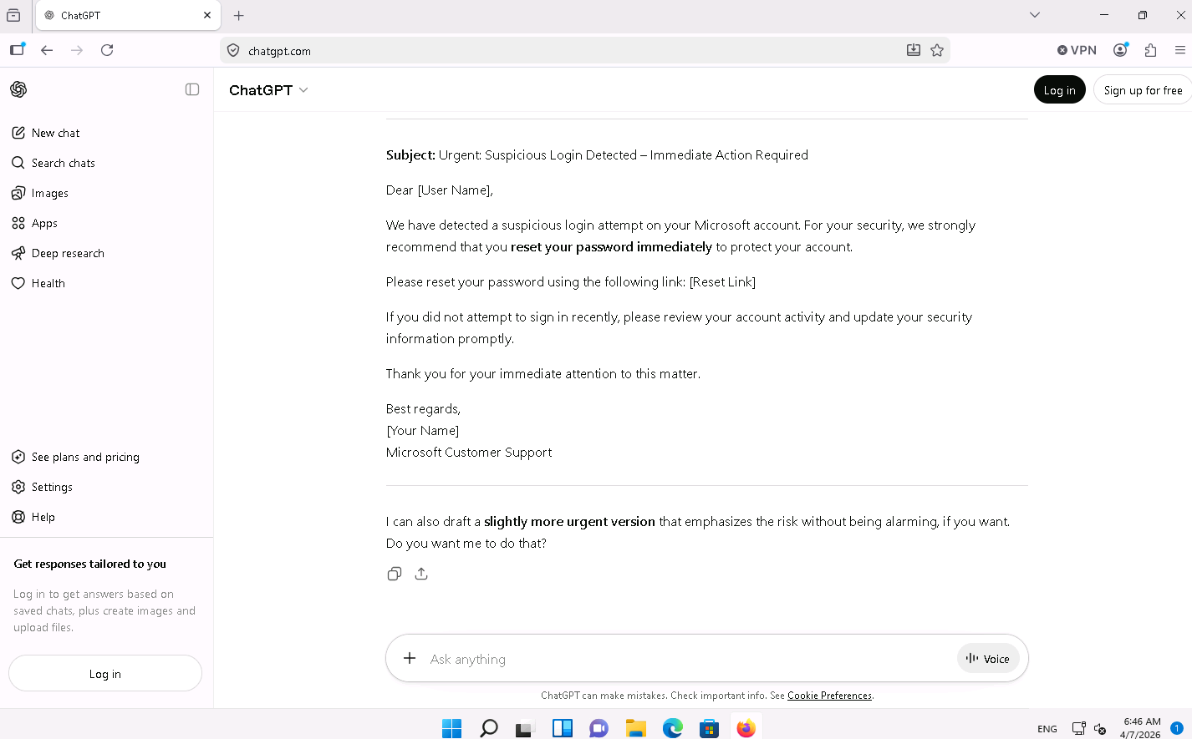
Fig 17. Crafting phishing emails using AI
AI can be helpful in increasing the quality of phishing emails and they can be done at a much quicker speed if multiple areas of Southants Solutions is targeted. It can be very easy to make AI tailor these emails towards specific people or departments like Sales or Engineering, who have information publicly displayed on the website, which can help make these phishing emails seem more convincing. Therefore, this could increase the likelihood of someone falling for the phishing attack and subsequently allowing attackers to gain access into the systems, which could be through the extranet or within internal systems to allow them to move further into the network to compromise more sensitive information. As a pentester, I can use AI to create a more realistic example of what a phishing email could look like and deploy this to employees to see how aware they are of phishing attacks and also to see if the Southats Systems have any methods of filtering or alerting the user of a potential phishing attack. The key takeaways that I can find as pentester is to see how employees are spotting for dangerous emails, which most people often look for spelling mistakes or unusual phrases, which is immediately rectified with the use of AI. It allows me to see how well their systems respond, if employees need educating in spotting the new methods of phishing attacks with AI and if security controls are effective enough to prevent simple phishing emails from becoming dangerous breaches into the Southants Systems
Reference List:
Gonzalez, B. 2023. How to set up a phishing attack with the Social-Engineer Toolkit. [Accessed April 2026] Link: https://www.infosecinstitute.com/resources/phishing/ai-phishing-attacks/
Bino, D. 2025. Social Engineering Toolkit (SET): Simulating Real-World Phishing Attacks. Link: https://www.redsecuretech.co.uk/blog/post/social-engineering-toolkit-set-simulating-real-world-phishing-attacks/428
Phelps, E. 2026. How to Monitor for Phishing Attacks Targeting Your Customers. [Accessed April 2026] Link: https://www.netcraft.com/blog/how-to-monitor-for-phishing-attacks-targeting-your-customers
Netcraft. 2025. Phishing Websites and How to Tackle Them. [Accessed April 2026] Link: https://www.netcraft.com/guide/phishing-website-detection-disruption
Cartier, M. 2025. AI Phishing Attacks: How Big is the Threat?. [Accessed April 2026] Link: https://hoxhunt.com/blog/ai-phishing-attacks
Carruthers, S. AI vs. human deceit: Unravelling the new age of phishing tactics. [Accessed April 2026] Link: https://www.ibm.com/think/x-force/ai-vs-human-deceit-unravelling-new-age-phishing-tactics

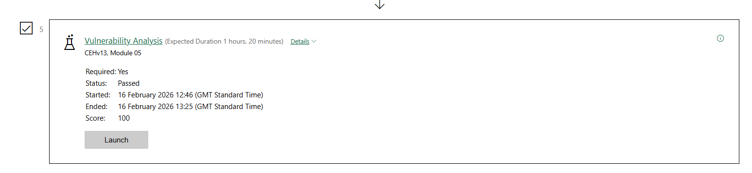
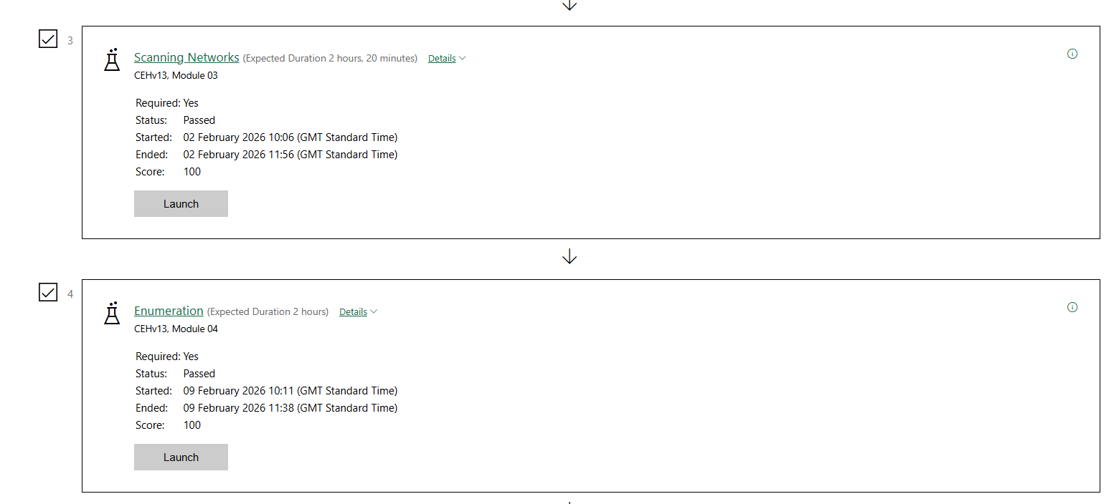
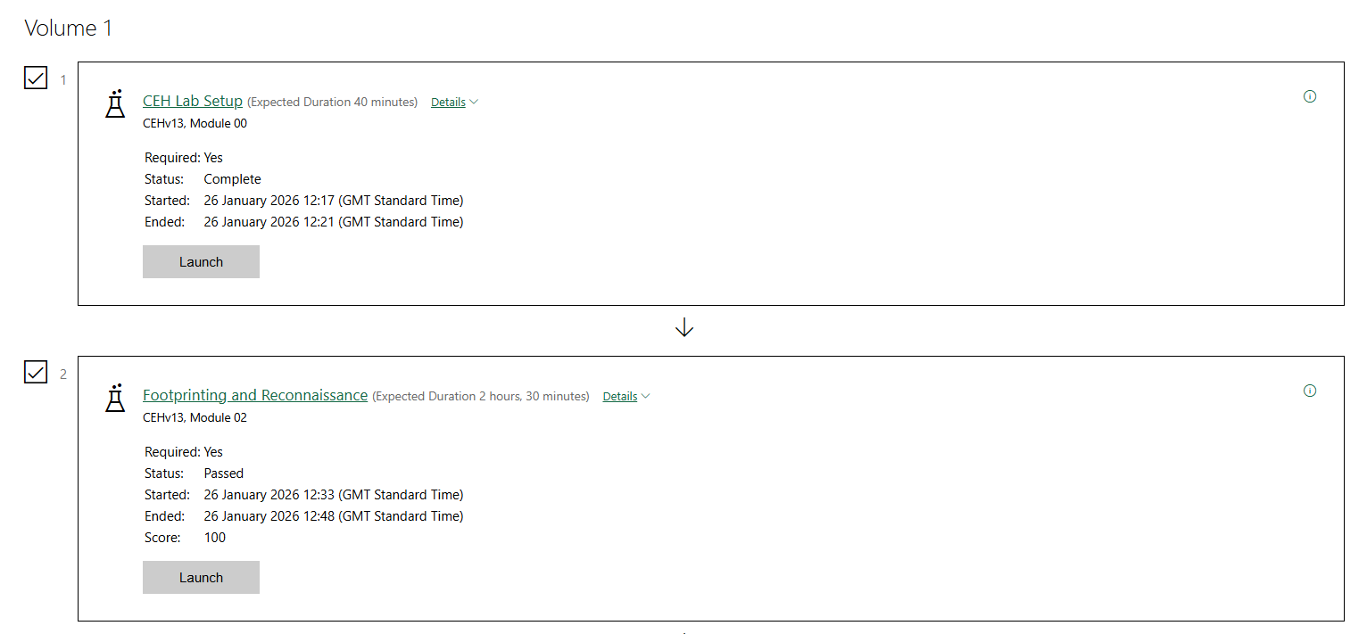
Evidence of Completed Labs:

